1. List down the method to perform PCA. Elaborate on each step.

PCA is a useful statistical technique that has found application in fields such as face recognition and image compression, and is a common technique for finding patterns in data of high dimension. There are different **steps** needed to perform a Principal Components Analysis on a set of data.

1. Step 1: Get some data

- In our example, we are going to look at a made-up data set containing only 2 dimensions

- Why only 2 dimensions:

* Easier to plot
* Can show the plots of the PCA analysis at every step

1. Step 2: Subtract the mean

-Subtract the mean from each of the data dimensions

-The mean subtracted is the average across each dimension

Exm: All the x values have x ̅ (the mean of the x values of all the data points) subtracted. Similarly done for y

Produces a dataset whose mean is zero.

1. Step 3: Calculate the covariance matrix

-This is done in exactly the same way as was discussed earlier

-Since the data is 2 dimensional, the covariance matrix will be:

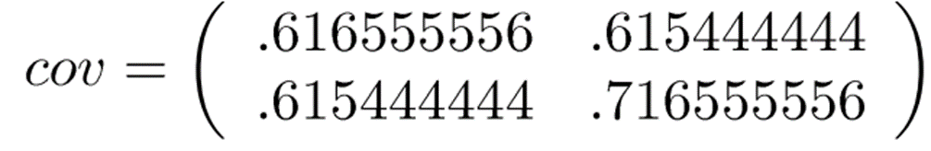

1. Step 4: Calculate the eigenvectors and eigenvalues of the covariance matrix

-Since the covariance matrix is square, we can calculate the eigenvectors and eigenvalues for this matrix.

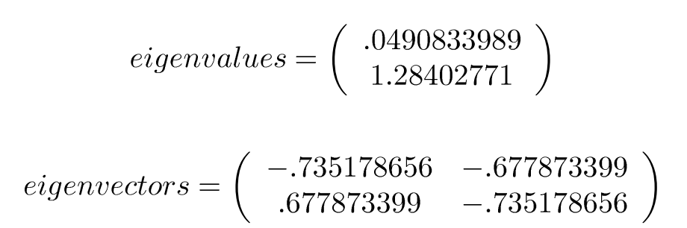

1. What do the eigenvectors of the covariance matrix give us?